Name =

Abubaker Attique

Roll no =

P20-0560

Class =

5-A

Lab Task 10

**Task 1:**

Determine Network Address of the following IP Address

Subnet mask bits: 30

IP address : 10.128.240.50.

IP To Binary conversion:

00001010.10000000.11110000.00110010

Subnet To Binary conversion:

11111111.11111111.11111111.11111100

AND OPERATION

00001010.10000000.11110000.00110010

11111111.11111111.11111111.11111100

---------------------------------------------------------------------------------

00001010.10000000.11110000.11110000

Network ID : we have derived the network id from the ANDing IP add and subM is:

00001010.10000000.11110000.11110000

Is equal to in decimal from 10.128.240.48

Broadcast :

The broadcast can be achieved by setting the LSB where the number of bits would be equal to the host number.

32-30=2

Hence the Broad cast is :

00001010.10000000.11110000.11110011

Is equal to in decimal form 10.128.240.51

Range :

It is equal to the number of the host in the network:

2^(number of host bits) - 2 = Number of hosts

2^2-2=2

Hence range will be from 10.128.240.49-10.128.240.50.

**Task 2:**

**Determine the network and broadcast addresses and number of hosts bits and hosts for the given IPv4 addresses and prefixes in the following table.**

**1) 192.168.100.25/28**

**Subnet Mask: 28**

**IP address : 192.168.100.25**

**IP To Binary conversion:**

11000000.10101000.01100100.00011001

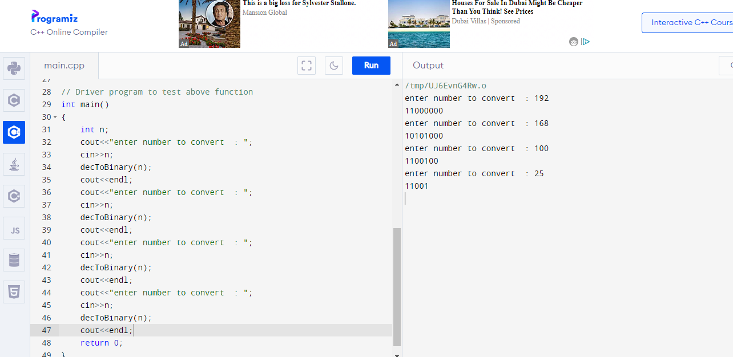

**Subnet Mask to Binary conversion:**

11111111.11111111.11111111.11110000

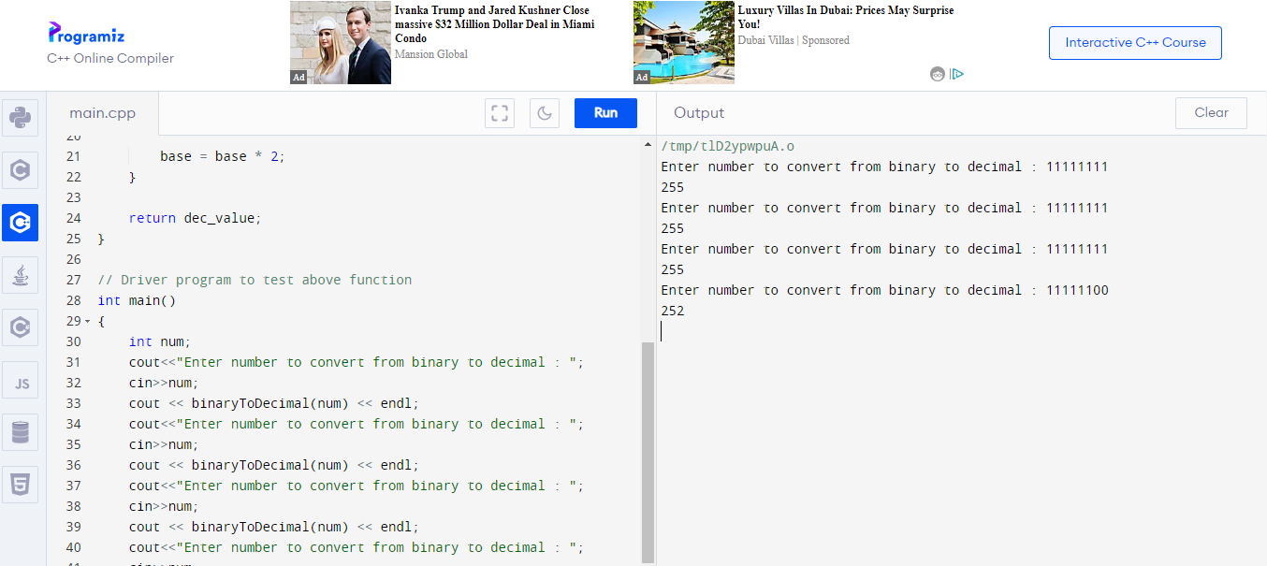

**AND OPERATION:**

01100000.00101010.00011001.00011001

11111111.11111111.11111111.11111100

01100000.00101010.00011001.00011000

**Broadcast:**

**The broadcast can be achieved by setting the LSB where the number of bits would be equal to the host number.**

**32-30 = 2 host**

**Hence the broadcast is**

**2) 172.30.10.130/30**

**Subnet Mask:**

**Ip address:**

**IP To Binary conversion:**

**Subnet Mask to Binary conversion:**

**AND OPERATION:**

**Broadcast:**

**The broadcast can be achieved by setting the LSB where the number of bits would be equal to the host number.**

**32-30 = 2 host**

**Hence the broadcast is**